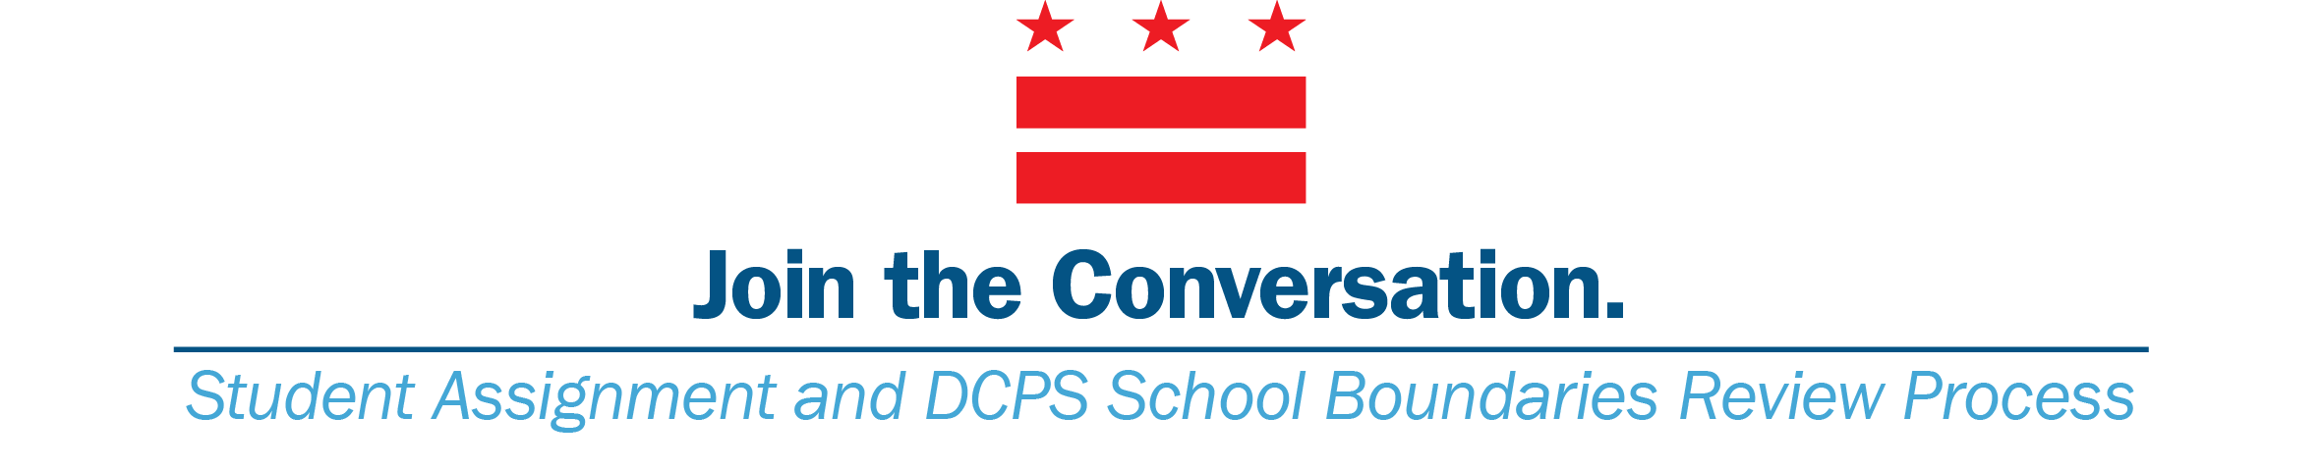
WARD OF RESIDENCE: _____ ASSIGNED SCHOOL: ___________________

WORKSHEET

- What suggestions do you have for the proposed boundary and feeder pathway revisions in your specific neighborhood and in general?

- What suggestions do you have for the proposed phase-in policies?

- Do you like the proposed policies increasing access for out-of-boundary and at-risk populations? What would you change?

- What particular neighborhoods have transportation challenges due to their geographic isolation or lack of good public transit options?

- Are the triggers proposed for opening a new school or expanding the capacity of a zoned school the right ones? Is there anything missing?

- What are your suggestions for policies we should consider to decrease student mobility?

